**Pyber**: Data Analysis

J. Curtis

Oct 27, 2018

This report summarizes data analysis for **Pyber**, a start-up ride-sharing company. I’ve analyzed your company’s ride records (comprising company data from January 1, 2018 to May 8, 2018), and have come to a few conclusions that should help your marketing team increase your profit per rider, better allocate your advertising, and compete for customers in new markets.

Your service considers three main service areas by type: Urban, Suburban, and Rural. These areas are defined by a company algorithm using population density and land-use categories (please contact me for more details on the algorithm if desired). When considering these categories, the largest in terms of total fares is clearly urban, at 62.7%. Urban areas also comprise 68.4% of the total fares, and 80.9% of total drivers (see figures 1 through 3).

These figures suggest an interesting fact: both suburban and rural types are punching above their weight in terms of total fares. Suburban areas, served by only 16.5% of your total driver population, are producing an impressive 30.5% of your total fares, while comprising only 26.3% of total rides. Similarly, rural areas, served by only 2.6% of your driver population, are producing 6.8% of your total fares, with 5.3% of total rides (see figures 1 through 3). It should increase your overall profit by marketing more to suburban and rural areas, both to capture additional high-fare traffic (possibly due to greater commute distances/traffic), and to grow your driver population there, potentially capturing more market-share from your competitors.

Considering most of your driver population and rides are taking place in urban areas, it seems prudent to try and capture higher revenue per driver, as systematic fee changes for urban areas should affect a larger population. Depending on the company’s strategy, it may be time to cut some of your original ridership bonus incentives in urban areas, as your market share has increased considerably since launch due to your driver customer-service training program. You could reinvest some of that money in improving your app’s performance in urban areas, which suffer from service dead spots on certain networks; this should help ridership, which should be the element to maximize in urban areas due to the generally shorter trips in a dense environment.

Analyzing the relationship between total number of rides per city and average fare, there are some distinct clusters for each area type (see figure 4). You should perform further investigation on areas at the horizon of this chart, which perform better than the majority. I’ve circled a few areas (in green) that represent your highest total value areas, especially the suburban areas which have a smaller proportional driver population, and hence lower aggregate wages paid and higher profit. It may be worth reaching out to drivers in these areas based on their own performance statistics to get their opinion on why and how they are successful; you could then share this information through intra-company communications. You could also perform additional geographic analysis to correlate higher performance with area characteristics not represented in the current data, and use that correlation to market for drivers in similar under-represented areas.

In summary, here are a few possibilities to increase profit per rider, allocate advertising, and compete for new markets:

1. Market more effectively in suburban and rural areas to capture high-fare traffic and market-share
2. Cut ridership bonus incentives in urban areas, reinvesting money in app improvements designed to increase ridership
3. Learn what’s working well in your most valuable areas (is it drivers and/or other area characteristics?), pass the information to drivers in other areas, and offer driver incentives in similar areas elsewhere if relevant

Figure 1

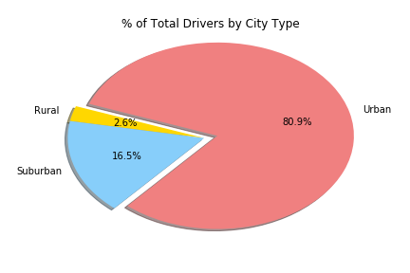

Figure 2

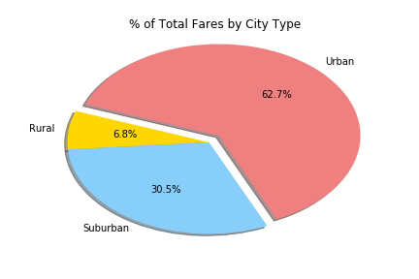

Figure 3

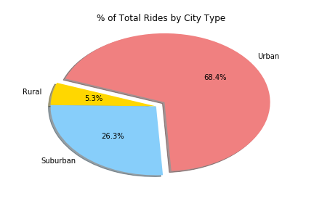

Figure 4

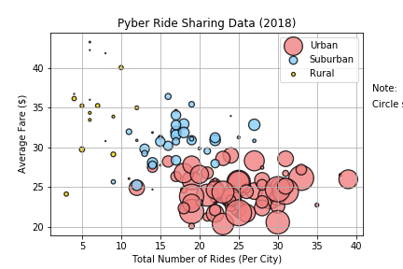

Note:

Circle size correlates with driver count per city

Green circle callouts represent high-value areas